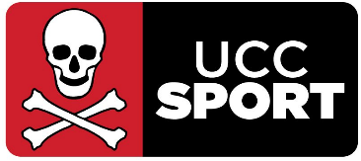

UCC HOCKEY: HEAD COACH WOMEN’S 1st TEAM
Part Time

UCC Hockey are wishing to appoint an experienced coach for the Women’s 1sts team who will compete in the EY Irish Hockey League Division 1 for the 2024/25 season. The successful candidate will report into the Head of Sport and Physical Activity and work closely with the Hockey Development Officer and Performance Manager.

The student team is categorised as a Performance Team and with the support of UCC Sport and other services/supports, the candidate will play a lead role within this support structure.

Applicants require a minimum of a Level 2 coaching qualification or equivalent and/or previous coaching experience at senior club/provincial level.

The successful candidate should:
- Lead training sessions to develop players skills, tactics and fitness
- Create game strategies and provide guidance during matches
- Available to coach training sessions at least twice weekly, games generally on Saturdays (home and away with games in Ulster and Leinster), along with preseason training July/August, put time into analysis of games and player feedback. Intervarsities will also form part of the team’s competition programme
- Have a track record of success and achievement in a previous hockey role at school, club, provincial level or equivalent
- Foster a positive team culture and encourage player development
- Provide their vision for the team for the coming year and future seasons
- Collaborate with UCC Sport and use the supports it provides for UCC Hockey as a whole
- Work with other coaches within the club, supporting player development throughout the club and provide advice as required
- Have excellent communication skills

Potential candidates please email your interest and Hockey CV to Jeff Gomez at J.Gomez@ucc.ie by 5pm Friday 7th June

For further information on the Department of Sport & Physical Activity please visit www.ucc.ie/en/sport

No late applications will be accepted.

