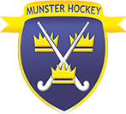

Job Description Ordinary Member

- Attend Management Committee Meeting
- Attend Interpro Interviews and debriefs in the event of key management being unavailable.
- Take gates at cup finals, help out when hosting Interpros & internationals in Munster
- Support in any area where possible within the running of Munster Hockey

