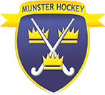

PRO

CORE RESPONSIBILITIES:

- Responsible for the promotion of hockey in Munster;
- Owner of all social media outlets;
- Creating content to actively promote the game of hockey;
- Manage the website;
- Seek sponsorship;
- Send weekly reports and fixtures to media outlets;
- Synopsys of position of Chair of MHUA.

